Introducing the Nonqualified Plan Exit Strategy to Mitigate FIVE Perpetual Risks

A Brief, Informative White Paper for Employers and their Executives
July 2020

By William L. MacDonald
Managing Director, EBS
While nonqualified deferred compensation (NQDC) plans and supplemental executive retirement plans (SERPs) are a tax-efficient way to restore benefits lost to the limits in IRC sections 415 and 401(a)(17), NQDCs and SERPs are not the best way to take retirement income or transfer wealth to the next generation. Five risk factors surround these arrangements, which you can avoid at retirement.

Allow me to save you time and parse out the core message of this paper in the bullet points below:

- To help executives maximize income at retirement and build wealth for future generations, some executives are taking advantage of a new strategy, the NQDC Exit Strategy. Executives can exit heavily taxed retirement benefits for uniquely designed tax-favored life insurance funded contracts on the life of the executive or the executive and his or her spouse.

- If an executive decides to use the NQDC Exit Strategy, it does not require any company approval, as this is an individual decision and has no impact on the employer’s plan.

- The NQDC Exit Strategy can be used with all deferred compensation arrangements including SERPs, NQDC, stock deferral plans, and nonprofit organizations’ 457(b) and 457(f) plans.

- The NQDC Exit Strategy has the potential to create greater after-tax income at retirement over what the executive could do on their own in an individual investment portfolio. Section 409A was added to the Internal Revenue Code, effective January 1, 2005, under Section 885 of the American Jobs Creation Act of 2004 and added complexity to an executive’s decision making options for retirement income.

The effects of Section 409A are far-reaching, because of the exceptionally broad definition of "deferral of compensation." Section 409A was enacted, in part, in response to the practice of Enron executives accelerating the payments under their deferred compensation plans in order to access the money before the company went bankrupt, and also in part in response to a history of perceived tax-timing abuse due to limited enforcement of the constructive receipt tax doctrine.

The adoption of 409A has made it more difficult to add flexibility into an executive’s retirement options.
This paper focuses on the distribution of dollars from deferred compensation arrangements and introduces you to a concept that executives are finding attractive, The NQDC Exit Strategy.

Current Distribution Options
In most 409A-compliant NQDC plans, a participant can defer compensation to a future date and take distributions in a lump sum or over time. As an example, an executive could defer 2020 bonus compensation, and elect to take that money at retirement over 5, 10 or 15 years. The advantage to installments is the continued compounding of tax-deferred earnings on the unpaid balance.
For those deferring in high income states like California or New York, and retiring in much lower tax states, they can minimize or eliminate the state tax with proper planning, using the Source Tax Law.
Typically, an individual is subject to income taxation by the state in which he or she lives when the income is received. Some states, however, attempt to tax nonresidents on this income on the basis that it was earned, or had its source, in the first state. Retirement income has been a key target of this type of state taxation. Under the federal "Source Tax Law," however, retirement income meeting certain conditions will be taxable only by the recipient's state of residence at the time of payment, regardless of its "source."
"Retirement income" also includes certain income from nonqualified deferred compensation plans. Specifically, amounts payable from such plans will be protected if either:
- The income is part of a series of substantially equal periodic payments (not less frequently than annually) made for 1) the life or life expectancy of the recipient (or the joint lives or joint life expectancies of the recipient and his or her designated beneficiary); or 2) a period of not less than ten years.
- The income is a payment made: 1) after termination of employment; and 2) under a plan, program or arrangement maintained solely for the purpose of providing retirement benefits for employees in excess of the limitations imposed by one or more of certain enumerated sections of the Code applicable to tax-qualified retirement plans ("Excess Plans").

Risk Factors in Multiple Year Distributions from NQDC

Despite the benefits, many executives with large account balances have elected to take lump-sum payments at retirement due to five risk factors which include:
- Creditor Risk. Participants in a NQDC plan are subject to the claims of the employer’s creditors. If the sponsoring employer becomes insolvent, participants stand in line as an “unsecured general creditor.”

- Income Tax Risk. Distributions are taxed at the current tax rates in place at the time of distribution. Rates may increase in the future, especially with the increase of Federal spending around COVID 19.

Risk Areas

- Market Risk. To maximize returns, participants are investing in a portfolio of investments that include equities. Based on market performance, their annual distributions will vary based on their account balance and can fluctuate in retirement.

- Liquidity Risk. Once an executive locks in the payment stream and starts to receive distributions, 409A does not allow them to change their elections. If higher taxes or market returns cause lower distributions, he/she cannot access additional funds unless they can prove a hardship – which is challenging to do in NQDC plans.

- Estate Tax Risk. NQDC plan assets are, in most cases, includable in the executive’s personal estate.

Many executives are implementing programs to help mitigate these risks.

The NQDC Exit Strategy
The NQDC Exit Strategy is one pathway to maximize retirement income and create wealth for future generations because you generate liquidity and tax-free income. Also known as a preservation of wealth plan, a benefit exchange, or a benefit swap, the arrangement allows participants to exchange heavily taxed retirement benefits for a secured, tax-deferred arrangement that provides ample flexibility to the executive. The favorable tax treatment of the NQDC Exit Strategy uses life insurance to help produce potentially more wealth accumulation and tax-free income at retirement.

Multiple Taxation Cuts into Retirement Benefits

When a participant takes a distribution from a NQDC plan, they are hit by several taxes.
Taxes can consume 83 percent of assets and future growth, and in some states, much more.
- Federal and state income taxes
- Capital gains taxes on money distributed and re-invested
- Estate taxes on balances and distribution if held
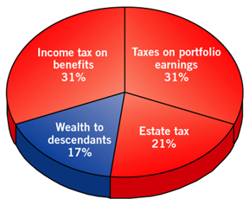
Source: Executive Benefit Solutions

The NQDC Exit Strategy is a somewhat complicated financial and tax strategy. Experienced practitioners must help clients determine benefits desired, plan mechanics, and the optimal life insurance arrangement and financing to be applied.
It is also essential for financial managers to understand how these arrangements work so they can help their executives assess the consequences of using this strategy. The good news is that this is an individual program and does not need any employer decision or modification to the current NQDC plans to adopt.
This strategy can also be used for SERPs and other deferred comp arrangements, including restricted stock unit deferral plans and 457(b) and 457(f) distribution plans for nonprofit organizations.
Compared with Alternative
The best way to grasp the advantage of the NQDC Exit Strategy is to compare it with the executive taking a lump sum in cash at retirement from his NQDC plan and investing the after-tax amount into a personally managed portfolio. Unfortunately, that is his only option, as NQDC plans cannot roll over funds into an IRA like qualified plans.

In our example, Bob Smith, a 58-year-old executive, is planning on retiring in seven years (age 65) and has elected to take a lump-sum payment to avoid some of the risks we discussed earlier. Today, his account balance is $5,000,000, and we are assuming he will earn five percent interest over the next seven years.
In our example, his account balance would grow to $7,035,502 at five percent in seven years. At his current lump-sum election, and assuming a 40 percent tax bracket (state and federal), he will net out $4,221,301. He can use this money toward his retirement income.
Planning for Retirement
Like most executives, Bob has additional assets that he has earmarked toward his retirement goals. He’s accumulated shares of company stock through various programs, is holding unvested restricted stock units (RSUs), and has stock options. He also has a 401(k) plan, IRA Rollover account, and an investment portfolio. Let’s look at the asset breakdown:
- Company stock 3,100 shares at $154 $ 477,400
- RSUs value 206,300
- Gains from stock options 196,000
- 401(k) balance 1,200,000
- Investment portfolio 1,427,000
Bob’s employer has provided him with a financial coach through a financial planning service with www.myfinancialcoach.com.
In working with his Certified Financial Planner® (CFP®) coach and using My Financial Coach tools, they mapped out retirement projections based on Bob’s goals. Since he owns several assets, he doesn’t need to withdraw his nonqualified plan money for a few years.
However, because he is concerned with the risk factors discussed earlier, he plans on taking a lump sum at retirement and moving those funds into the NQDC Exit Strategy, and holding off on taking distributions for five years, until age 70. The 401(k) can be rolled over, and he does not have to begin receiving money until age 72 under the Required Minimum Distribution (RMD) rules.
Bob and his CFP® planner have developed a strategy for his retirement. Rather than put additional dollars into the NQDC, they decided to begin funding a Roth plan. With the 401(k), they chose to go with the Roth election to have more tax-free dollars in retirement.
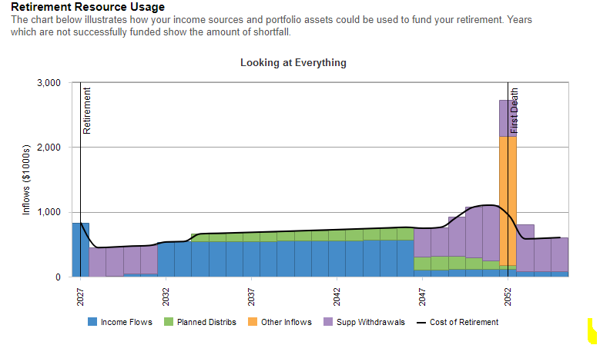

An executive’s financial position determines the advisability of his or her participation in and application of an exit strategy. The Exit Strategy can be customized to meet the executive’s personal goals for retirement. Executives often designate these income sources as eligible for a possible exit from:
- Deferred compensation balances
- Accrued SERP pension benefit obligations
- Stock option gains and restricted stock
- Distributions from 457(b) and 457(f) plans

Some executives use this strategy for wealth transfer, which we will discuss later.

The Plan Mechanics
The NQDC Exit Strategy begins with the purchase of an Indexed Universal Life (IUL) policy or a Variable Universal Life (VUL) policy with Index options (similar to those offered in an IUL policy). The coverage is on the executive’s life, or jointly with his/her spouse, and is purchased now, prior to the lump sum distribution at retirement in order to save age on the insurance and have a mature policy in place at the time of the transfer of the NQDC plan money.
To minimize the cost, a bank is used to finance the premiums. The premiums plus accrued interest will be paid back in seven years (see chart below) using the after tax proceeds from the lump sum distribution.
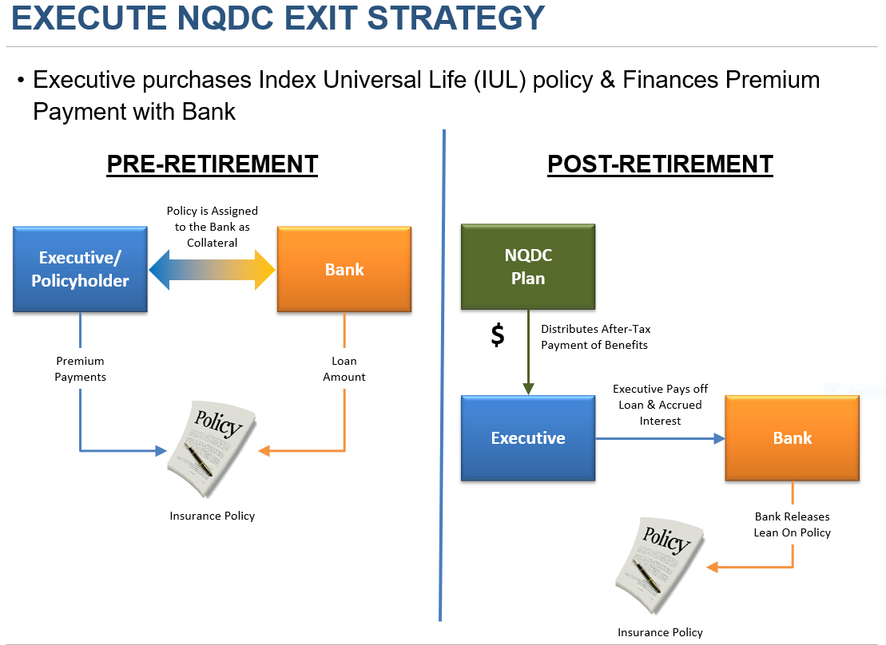
Bank Releases
Lien on Policy
The premium for the IUL policy is determined based on the projected after-tax distribution the executive will receive in seven years. From our example, Bob will have $4,221,301 after-tax. So we want that number to be enough to pay off the premium financing and accrued interest. See chart below.

Assumptions: Cash value earnings: Indexed to the S&P 500 (excluding dividends), collared with a 9.5% cap and a 1% floor. Insurance policy crediting rate is assumed to be 6%. Assume the bank loan at 4.00%.

When Bob’s Deferred Compensation balance is distributed at age 65 in a lump sum, the after-tax proceeds are used to liquidate the loan taken out to purchase the policy. He then has full control of the unencumbered policy. He does not need to conform with 409A requirements, restrictions, or distribution dates. He has complete flexibility on when and how he withdraws non-taxable cash from the policy. This flexibility is now a tax-deferred asset on his personal balance sheet.
In our example, Bob, working with his CFP® coach, anticipates taking distributions beginning at age 70, five years after retirement. Working with EBS’s administration system, Bob starts to make tax-free distributions based on withdrawals up to basis (basis means premiums) then loans from the policy. Based on an assumed earnings rate in the policy of six percent, he can take $463,888 per year for 15 years. See chart below.
Assumptions: Cash value earnings: Indexed to the S&P 500 (excluding dividends), collared with a 9.5% cap and a 1% floor. Insurance policy crediting rate is assumed to be 6%. For the investment account, assumes pretax investment rate of 5.00%, a blended tax rate of 35.00% and a resulting net after tax investment rate of 3.25%.

As you can see from the above chart, the NQDC Exit Strategy produced $820,862 more income over the 15-year period ($6,958,323 vs. $6,137,461). In addition, Bob has a death benefit of over $400,000 payable to his beneficiaries if death occurs at age 85. The projected results for the Personal Investments is based on current tax rate assumptions - if tax rates go up, the gains would be larger for the NQDC Exit Strategy.
The NQDC Exit Strategy for Wealth Transfer
Some executives have done an excellent job planning for retirement, and do not need to draw down a steady stream of income from the NQDC Exit Strategy. They may be interested in keeping the death benefit as high as possible, using the tax-deferred growth of cash value to generate an increasing death benefit. They also may be interested in using the policy for its death benefit in estate planning and could transfer the policy to an irrevocable trust that would be exempt from taxation upon their death.
If Bob decides to do that, the following chart illustrates his projected insurance death benefit compared to what the after tax lump sum distribution from the Deferred Compensation Plan could accumulate to in a personally managed investment portfolio.
Assumptions: Cash value earnings: Indexed to the S&P 500 (excluding dividends), collared with a 9.5% cap and a 1% floor. Insurance policy crediting rate is assumed to be 6%. For the investment account, assumes pretax investment rate of 5.00%, a blended tax rate of 35.00% and a resulting net after tax investment rate of 3.25%.
Brief Explanation of Risks
There are potential risks associated with the NQDC Exit Strategy, as outlined below:
- Interest Rate: The risk that the interest rate on the premium financing loan increases significantly.¹
- Policy Performance: The risk that the future cash value earnings are not as high as expected/ projected.
- Tax Law: The risk of an adverse change in tax law impacting the existing tax benefits of life insurance contracts.
- Early Exit: The risk of incurring additional costs to unwind the arrangement in the first few years, if necessary, for some unexpected reason.
- Surrendering the insurance policy. The surrender of your policy may result in taxable gain. If the executive surrenders the life insurance policy, any gain on the policy will be subject to federal (and possibly state) income tax. Your basis is the total premiums that you paid in cash, minus any policy dividends and tax-free withdrawals that you made. That is why we structure this arrangement and administer it never to surrender the policy.
¹Note: This situation is generally only an issue if the plan is structured for repayment of the loans from the cash value of the policy (which may be inadequate in the early years to cover repayment). It would not be an issue in this case since the plan is to repay the premium loans from the deferred compensation benefits. In addition, it’s possible to lock-in a loan rate for a period of time that might cover the intended term of the loan.

Benefits to the executive
The benefit to the executive, once they take distribution from their NQDC plan, is that they are no longer subject to the claims of the employer creditors, locked into distribution elections, or subject to increased tax rates on distributions. Executives are in control of their funds.
The NQDC Exit Strategy offers executives the ability to accumulate funds tax-deferred and the ability to withdraw from the insurance policy on a tax-free basis. The economics of this tax-deferred growth in our example above shows a $820,862 gain over personal investing. And for those that want to transfer wealth, you can pay heirs income tax-free and, with proper planning, estate tax-free because of the substantial life insurance benefit.
Benefits to the company
The NQDC Exit Strategy is a personal decision of the executive and does not involve their employer. The employer does not have to change or modify their plans to make this work.

The Optimal Insurance Arrangement
Participants can choose from among many different types of insurance policies for an NQDC Exit Strategy, including general account (UL), index universal life (IUL) and separate account products (VUL), single life, and second-to-die (survivorship). These policies can be “retail” or proprietary products. The decision on the type of policy is based on the executive’s objectives.
General and separate account. General account life insurance invests policyholder cash values in the insurance carrier’s general asset portfolio. Policyholders earn a relatively safe, bond-like return and are general creditors of the insurance company. Many carriers also maintain a segregated asset account for variable, or “separate account,” policyholder cash values. The separate account includes numerous subaccounts, or investment portfolios managed by professional money managers. While you insulate the cash values from the carrier’s general creditors, policyholders assume the investment risk of their chosen asset allocation.
Index Universal Life (IUL). Indexed universal life insurance, or IUL, is a type of universal life insurance. Rather than growing the account based on a fixed interest rate or the variable results offered by a separate account allocation, the investment return is to the performance of a market index, like the S&P 500.
However, unlike investing directly in an index fund, the crediting rate earned in an IUL policy has a Floor, or minimum rate. This Floor is typically 0% or 1%, so if the underlying index that’s being tracked is negative for the period, the crediting rate will be no less than the Floor. On the other hand, in exchange for downside protection, there is usually a cap on the maximum return you can earn (i.e., floor of 1% with a cap of 9.5%). Most NQDC Exit Strategies are typically funded with IUL to take advantage of market driven returns with downside protection.
Single life and survivorship. A married participant may choose to insure his or her spouse’s life as well, to reduce the policy’s insurance costs. In addition, death proceeds at the second death will coincide with the largest estate transfer costs, providing funds to help beneficiaries pay estate taxes on other assets.
Proprietary insurance products. When buying life insurance, executive and corporate insurance buyers generally have superior purchasing power. An NQDC Exit Strategy participant should be eligible for institutionally priced products designed specifically for this market. These products have lower insurance charges and lower loads than off-the-shelf products sold to the mass market. They also have high early year cash values to be used as collateral for the premium financed loan.
Funding strategy. Funding the insurance contract at the maximum (seven-pay) premium level enhances performance by minimizing annual mortality costs. Depending on the participant’s age, this strategy usually produces higher death proceeds at life expectancy. An appropriate insurance contract should have exceedingly high first-year cash values and no surrender charge.

Tax Considerations
The NQDC Exit Strategy is powered by life insurance for its tax advantages.
- The death benefit is generally paid out income tax-free; if designed for wealth transfer planning, it could be estate tax-free as well.
- The total cash value accumulates on a tax-deferred basis.
Life insurance builds up cash value over time as you pay premiums. This build-up is money that grows without the IRS taking a bite. And it can become an important asset for your future retirement.
- You can access the value of the policy on a tax-advantaged basis.
Money borrowed or taken from the cash value of a life insurance policy is not subject to taxes up to the “cost basis”— the amount paid into the policy through premiums.
To understand how this works, take our earlier hypothetical case of Bob Smith, who purchased his IUL policy as part of the NQDC Exit Strategy. There are a couple of ways that Bob could access his policy cash value during retirement:
- First, Bob has a cost basis in his policy of $3,464,270 (the total premiums he paid of $692,854 for five years). He could take a partial surrender of the cash value from his policy up to this amount, and it would be income-tax free.
- What’s more, Bob has the option to borrow against his cash value at any time. The amount borrowed will not be taxable as income, even if it is more than his cost basis. Unlike bank loans, you do not have to pay them back; they simply reduce your cash value and death benefits. The insurance company charges interest on those loans, but with most policies credits back the majority of what it charges.
Taxation of deferred compensation payout. Distributions to employees from NQDC plans are considered wages subject to income tax upon distribution.
This is the same tax treatment the executive would have even if they did not participate in the NQDC Exit Strategy.
A Deal Worth Your Consideration
A carefully structured NQDC Exit Strategy can provide a tax-efficient alternative to nonqualified benefits to accommodate an executive’s retirement income and wealth transfer strategy. This strategy can eliminate the five significant risks of NQDC plans and put the executive in control of their assets. The Exit Strategy introduces important financial, tax, and accounting considerations potential participants and outside advisers must evaluate.
ABOUT EBS
EBS is an independent executive benefits consulting firm which provides total plan management services with respect to programs specifically designed for key employees and professionals. Those services include:
- Consulting with respect to plan design,
- The structuring of related financing and benefit security arrangements,
- The design and management of participant communication, education and enrollment processes,
- Management of any informal funding assets and,
- On‐going plan administration and technical support.

More information about the firm can be found at: www.executivebenefitsolutions.com.
For more information on how you can introduce the NQDC Exit Strategy to your executive benefits plan, we invite you to contact one of our managing directors nearest you:
CONTACT INFORMATION:

